JacqCAD running on Mac OS 9 in the SheepShaver for Windows emulator

Quick and dirty checklist (current as of 31-July-2011):

-- Operating Systems –-
- Windows XP SP3 or Windows 7 x86 (32bit) installed on target PC (OS testing, like Vista/Win7 x64, in-work)

- Mac OS 9.0.4 CD or image (.iso) file *

-- Windows components –-
- GTK+ libraries 2.10.13 **

- SheepShaver “GUI and other files” download build 05_05_2010
Optional: SheepShaver build 30_08_2010 with startup sound (same download link)

-- Mac OS 9 components --
- Stuffit Standard 7.0.3 – only need the free Expander in Standard Ed *** Alternate link

- iMac update 1.1 - for "new-world" ROM file – don’t use Mac OS Rom update 1.0 (details below) **** original Apple link

- TomeViewer 1.3d3 - to extract ROM from iMac 1.1 update file
Cnet , Tucows , Emaculation

- JacqCAD 4.33b1 30-July-2011 (latest release) older releases also available

Notes:
→ No direct download links to files – for respective author/site credit.
* Mac OS 9.2.2 was the latest released by Apple. The SheepShaver emulator only supports up to 9.0.4
** GTK+ 2.10.13 is an older version than on GTK+ website, but confirmed to work.
*** Stuffit Expander (free download) is not available on SmithMicro’s “downloads” webpage. Get the full standard (update) through their support page.
**** Sheepshaver for Windows works best with new-world ROM and Mac OS 9.0.4. The Mac OS Rom update 1.0 is for the Blue and White G3 and CRASHES the emulator. Use the one from the iMac update 1.1

Preface:
Finding all the "stuff" (apps, utilities, ROM's etc.) was really the toughest part of getting this to work. I have provided almost all of what you will need above; the rest are found on the net.

Rest assured, one all the pieces are gathered, you should have little to no problems with functionality.

Once you get it all together, it is as easy as installing GTK+ libraries and coping/pasting your SheepShaver folder to the target PC and launching it!

My goal is to provide a reliable procedure to get to this point.

Intro:
Have you ever found one of those computer programs that you found to be "the right tool for the job" and then find out that the software is no longer able to run on your new hardware or new operating system (OS)? JacqCAD is one of these applications. Yes, there may have been newer/bigger/better software solutions that come along that attempt "absorb" the older stuff, but fall short on some critical functionality that was heavily relied upon. This is why I am glad a few smart folks created emulators to help bridge the gap between the old and the new.

Why would I do this?
(1) My wife is a college Textiles major and uses embroidery software such as 4D/5D Embroidery from HusqVarna Viking® and Texcelle® from NedGraphics®. These are Windows PC-based programs where as JacqCAD® is a Macintosh based program - actually a classic Mac OS (e.g. Mac OS 9.x) application. My goal is to put all of these applications on one Windows laptop for my wife's work.

(2) Garth Fletcher, the creator of JacqCAD, supported and encouraged a write-up to share my results.

(3) I like working with emulators!

My personal bias:
Mac's niche in the past was graphics, digital video, layout and design. I think Mac software outperforms PC software on most of these tasks. However, this is NOT a Mac vs. PC battle, there are plenty of other websites for that and I use BOTH regularly. The OS is less interesting to me than the application(s) I am running on it to get something done.

Options for running JacqCAD (FYI, this write-up targets #4)
JacqCAD is designed to run on PowerPC (PPC) hardware. Avenues for achieving this are:

(1) A PPC based Mac capable of booting Mac OS 9.x (latest version: 9.2.2). This is what as known as a native environment that does not require any form of emulation. Garth's notes about purchasing one of these older PowerPC based Macs (G3, G4, G5) can be found at the bottom of the page. They are fairly cheap and Mac’s have a reputation for continued existence.
  - PPC based Macs that can run Mac OS 9 natively info:
    - http://support.apple.com/kb/ht1835
    - http://en.wikipedia.org/wiki/Mac_OS_9

(2) A PPC or Intel-based Mac that runs the Mac OS X Classic environment:
- Mac OS X 10.4.11 (latest Mac OS X "Tiger" release) was the last Mac OS X to support the classic environment. It was dumped by Apple in OS X 10.5 (Leopard) and 10.6 (Snow Leopard). Just boot up Mac OS 9.x.x in the classic environment and run JacqCAD.

(3) A modern Intel-based Mac running OS X 10.5/10.6 and the SheepShaver for Mac OS X (versus for Windows) emulator. See Garth’s SheepShaver notes for Mac OS X

(4) A Windows PC running SheepShaver for Windows which is what this write-up is about!

(5) SheepShaver for Linux is available for those who would like to try it.

(6) PearPC is another PPC emulator that I have not tried, but may do so in the future.

Now the details:

SETUP:
[1] Get a Windows XP Pro PC updated to Service Pack 3 (SP3) and all current updates. I plan to test Windows XP x64, and Windows 7 Professional (64bit) and I will post my findings. Vista should work also.

Update July 2011: Windows 7 x86 (32-bit) also works!
JacqCad with SheepShaver | Windows XP (32bit) | Window XP x64 (64bit) | Windows 7 x86 (32bit) | Windows 7 x64 (64bit)
Tested good | X |  | X
Untested |  | X |  | X

Windows 7 (Professional, Enterprise, Ultimate) users: Although I have not tested it, I am confident that you will be able to use Windows XP mode in Windows 7! Reason is Microsoft uses a version of Virtual PC to achieve this. You also get a “free” copy of Windows XP out of the download. Unfortunately, if you have Widows 7 Home or Home Premium, you are not eligible for the Windows XP mode download (see link).

[1a] Create two folders: one for the SheepShaver install and one for the setup files. I use the following below (without quotes):
- I use ‘C:\Temp’ for my downloads
- I use ‘C:\SheepShaver’ for my installation, but you may also put it on your Windows desktop, it matters not.

Most of the following information comes from the SheepShaver for Windows webpage on Emaculation. I don’t want to repeat the same information, so I will try point out information for clarity and emphasis.

The following can all go in ‘C:\Temp’ for now:

[2] Downloads from SheepShaver for Windows

[2a] GTK+ 2.10.13 setup file.

Filename: gtk+-2.10.13-setup.exe

[2b] SheepShaver GUI and other files.

Filename: SheepShaver_05_05_2010.zip

Note: The SDL 1.2 Library (filename: SDL-1.2.13-win32.zip) is already included in the file above.

[2c] (Optional) SheepShaver for Windows, with startup sound.

Filename: SheepShaver_30_08_2010_startupsound.zip

I personally use this one. It has the old Mac hardware boot-up sound that old Mac (hardware) users remember! Although not required.
If you choose this, make sure to place the new .exe in the same directory with the included boing.wav file. You can actually have both .exe files (with and without startup sound) in the same directory and pick which one you want to use ☺

[2d] (Optional) Keycodes
See the SheepShaver for Mac OS X page, under Setting up SheepShaver #3 for a keycodes download link. This is only needed if a non-US English QWERTY keyboard is used. The “SheepShaver GUI and other files” has a Basilisk II keycodes file, but I did not use one.

[3] Download Stuffit Standard 7.0.3 from SmithMicro’s updates site: http://www.stuffit.com/support/updates.html

Filename: StuffitSTD703Classic.hqx

Note: This older version of Stuffit Standard will work with Mac OS 8.6 – 9.x. You only need the free Stuffit Expander component, which does not expire in 30 days. The current (free) Stuffit Expander page that would normally just let you download the free Expander does not let you go back this far, but the update site has the full Standard version.

[4] Download the iMac update 1.1 -- original Apple link

Filename: iMac_Update_1.1.smi.bin

This file has the "new-world" ROM file that will give us the best performance under SheepShaver. See the page tied to the link above and my notes below on ROM files!

BIG notes on ROM files:

The “SheepShaver GUI and other files” download above contains two ROM files – both without Windows file extensions:

- MAC_OS_ROM (1.9MB)
- MAC_OS_ROM_oldworld (4.1MB)

The first ROM is from the same Mac_OS_ROM_Update 1.0 file on the same Emaculation link above as the iMac update 1.1 – The 1.0 is for a Blue and White G3 ROM update and it CRASHES SheepShaver upon startup.

These ROM’s have already been extracted with TomeViewer, the iMac update 1.1 needs to be extracted (before Mac OS X installation packages, software was often placed in archives called tomes).

The catch-22 is that you need to be booted into Mac OS 9 to use TomeViewer. The plan is to boot our Mac OS 9 setup with the old-world ROM, use TomeViewer to extract the ROM from the iMac 1.1 update, zap the PRAM, and boot with the new-world iMac update ROM.
→ NOTE: See the 3rd bullet + Tip for “legal” info about Apple hardware ROMs http://emaculation.com/doku.php/sheepshaver_setup

Another excellent emulator Apple ROM reference on Emaculation.

[5] JacqCAD 4.33b1 (latest release) older releases also available, and they work!

[6] Mac OS 9.0.4 – two options:
(1) A physical CD
(2) An .iso file of the CD (select “read-only” attribute in Windows)

[6.1] I burned a Mac OS 9.0.4 CD and used it to install. All the information on either booting a physical copy or using an image file is laid out fairly straight forward in the Getting Started section here: http://emaculation.com/doku.php/sheepshaver_setup

[6.2] See the link above and reference the “For those without a physical Mac OS installation CD” If you have a Mac OS 9.0.4 CD, use the Apple DiskUtility to make an .iso file (not .dmg) and place this in your ‘C:\Temp’ as well – and right-click the file and select the “read-only” attribute. The rest is from the link above:

Next, run “SheepShaverGUI.exe” and in the “volumes” tab click “Add…” and then browse to and select your disk image. The ISO image should be at the top of the list of volumes. In this instance, you should select “boot from any.” Don't start the emulation yet.

Again, once everything is running, you will not use the burned CD or .iso file.

Look around the net for “SheepShaver+OS9” torrents and look at Redundant Robot’s site: http://www.redundantrobot.com/sheepshaver-tutorial/ the 120MB image should get you started!

Sidenote: Apple offers all their older OS’s as free downloads prior to January 1998. Unfortunately for us, these are prior to Mac OS 8.1 (e.g. System 7.5.3).

CONFIGURATION steps:

- Prerequisite: All needed files are in ‘C:\Temp’ or chosen download location on your Windows PC. If you are using a Mac OS 9 .iso file it can go here as well.

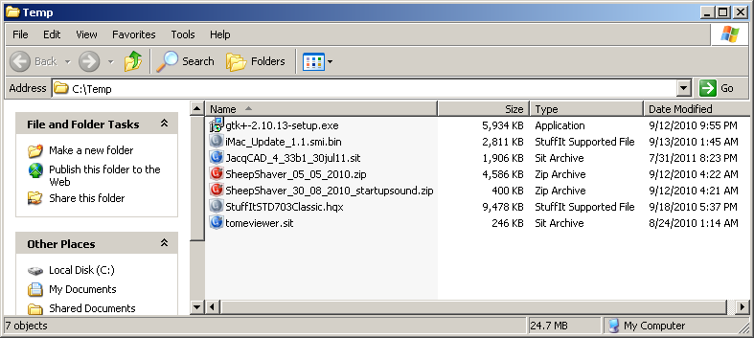

Note: the colored icons for the compressed files are because I have Stuffit Deluxe 2010 for Windows installed – this is not a requirement; it came bundled with my Stuffit Deluxe for Mac purchase ☺

- Install the GTK+ libraries
  - run: gtk+-2.10.13-setup.exe
  - accept defaults

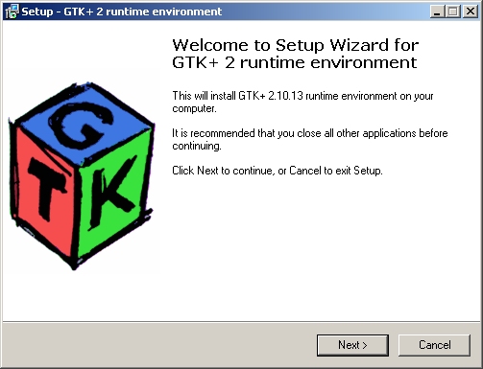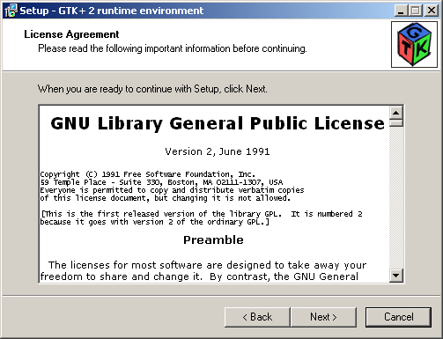

Select the default install location:

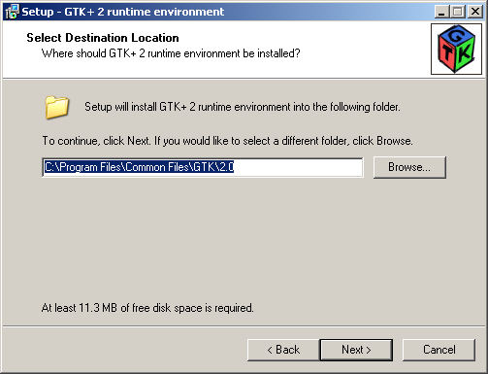

Select Full install…

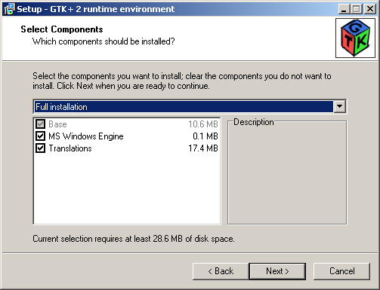

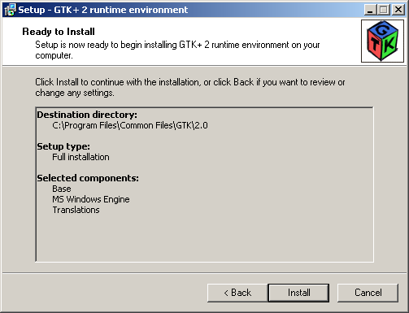

Installing …
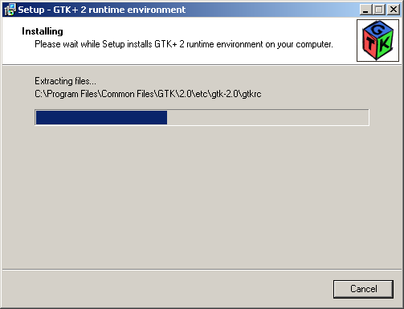
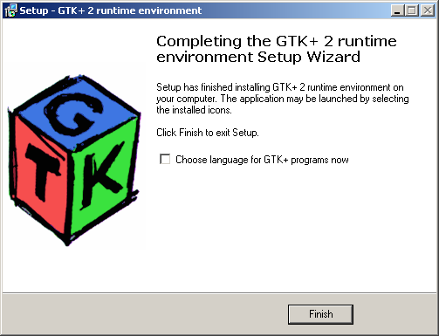

Note: The checkbox is optional if you just want the “default” language for your Windows OS.
- Extract SheepShaver
  - Un-zip SheepShaver_05_05_2010.zip
  - Copy the cd-rom dirver cdenable.sys to ‘C:\WINDOWS\system32\drivers’
  - (Optional) Un-zip SheepShaver_30_08_2010_startupsound.zip

Note: If you extract the SheepShaver to the root of ‘C:\’ it will extract to ‘C:\SheepShaver’ (the archive already has the ‘SheepShaver’ folder in it), if you extract to another directory, it will extract the ‘%dir%\SheepShaver’

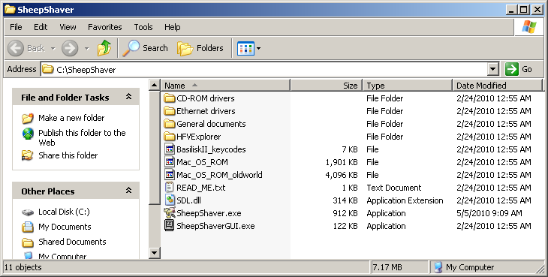

… If you have the optional startup sound files installed (I do):

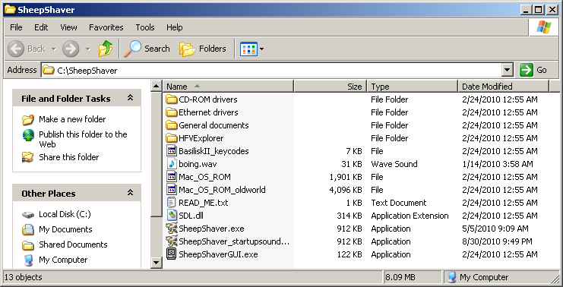

Navigate to the ‘CD-ROM drivers’ folder
copy the file cdenable.sys to ‘C:\WINDOWS\system32\drivers’ directory

This is SheepShaver’s cd-rom driver and will allow SheepShaver to boot the Mac OS 9 CD.

If you have a 64bit Windows, it should go in ‘C:\Windows\SysWOW64\drivers’ (not tested yet).

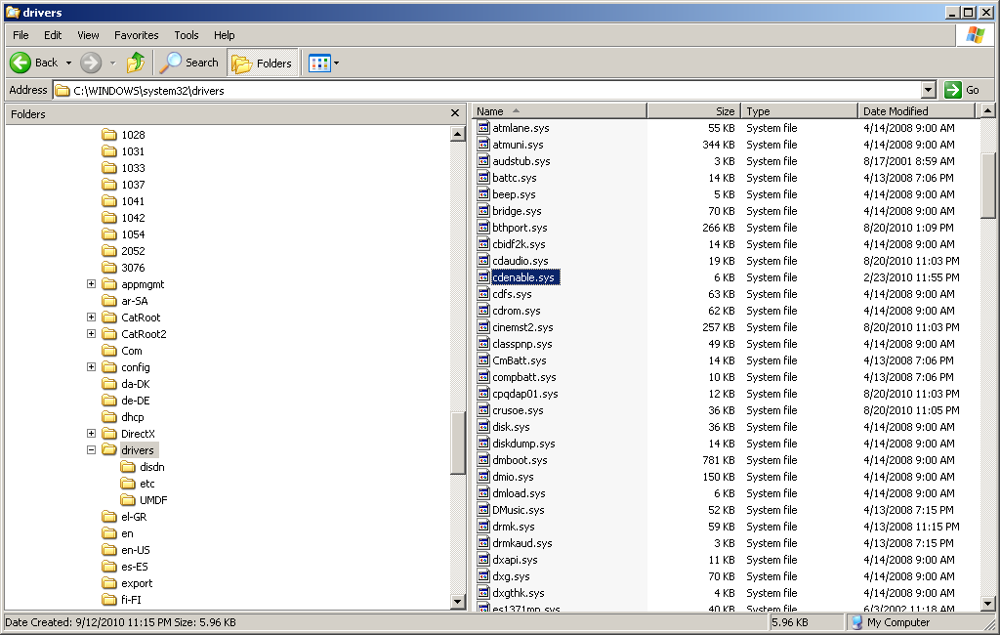

- Execute SheepShaverGUI.exe and configure – see SheepShaver for Windows
  - Select Volumes tab – click “Create…”
    - Create 1024MB or better hard drive image (max 2GB). I called mine MacOS9.hfv → include the .hfv extension!
    - If using .iso for Mac OS 9 CD, the .iso should be at the top of the Volumes list
    - If booting from physical CD, select the correct CD-ROM drive and select “Boot from CD-ROM” in the drop-down. If booting from an .iso file, select “Boot from Any”
  - Select enable “My Computer” icon on your Mac desktop (external file system—so you can get the JacqCAD program in Mac OS 9
  - Configure graphics resolution (suggest 800x600 or better)
  - Configure memory (suggest 256MB or better)

Startup SheepShaverGUI.exe

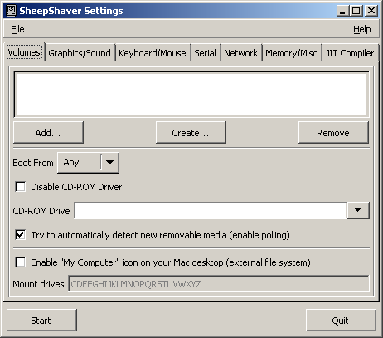

Click “Create…” – I named my hard drive image file MacOS9.hfv and changed the default 40MB drive size to 1024MB (1GB) – you may want this bigger (max 2GB)

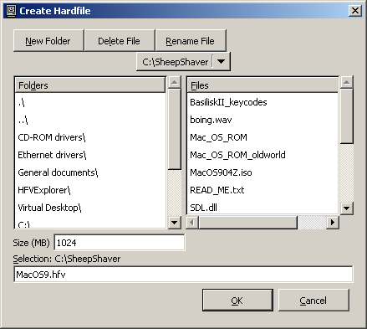

Insert your Mac OS 9.0.4 CD-Rom into you PC’s CD-Rom drive – or copy the .iso of the CD into the C:\Temp directory. The following screenshot will show the physical CD method.

Select:
1. CD-ROM drive that contains the Mac OS 9 CD (mine is E:\)
2. Select ‘Enable “My Computer” icon on your Mac desktop (external file system)’ –- so you can get the JacqCAD files in Mac OS 9!
3. Select “Boot from CD-ROM” drop-down if you have a physical media.

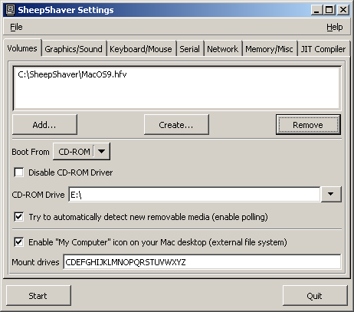

If you have an .iso, it should be in the Volumes at the top. “Leave the Boot From Any”. You can re-arrange the boot order by drag & drop.

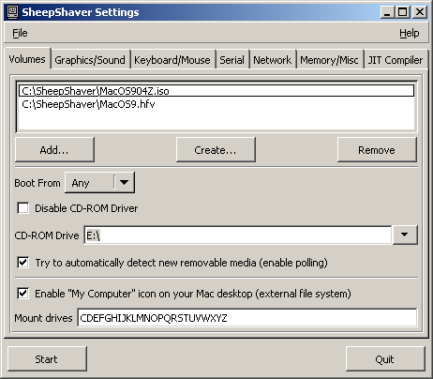

Switch over to the “Graphics/Sound” tab – for JacqCAD it is best to make the resolution larger than the default – either 800x600 or 1024x768. Leave all other default settings.

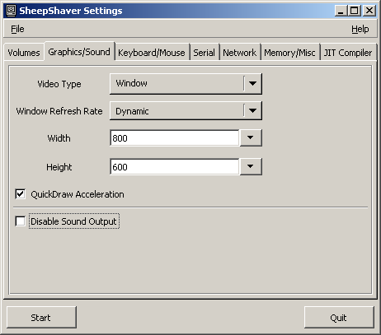

Now select the “Memory/Misc”
- This is where we select the old world rom file ‘Mac_OS_ROM_oldworld’ (no file extension) that came with the SheepShaver_05_05_2010.zip
- We will zap the PRAM and replace the old world rom with the new worl d rom (the iMac one) so SheepShaver will run optimally under OS9

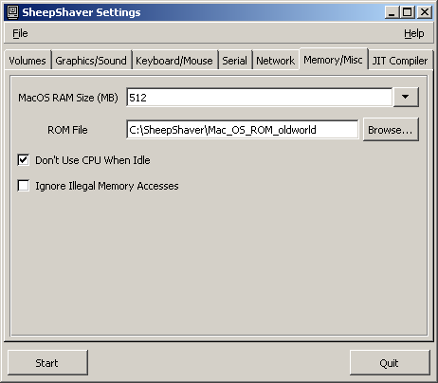

Select Start → Mac OS 9 should boot-up from the CD (or .iso file)
… and were off ☺!

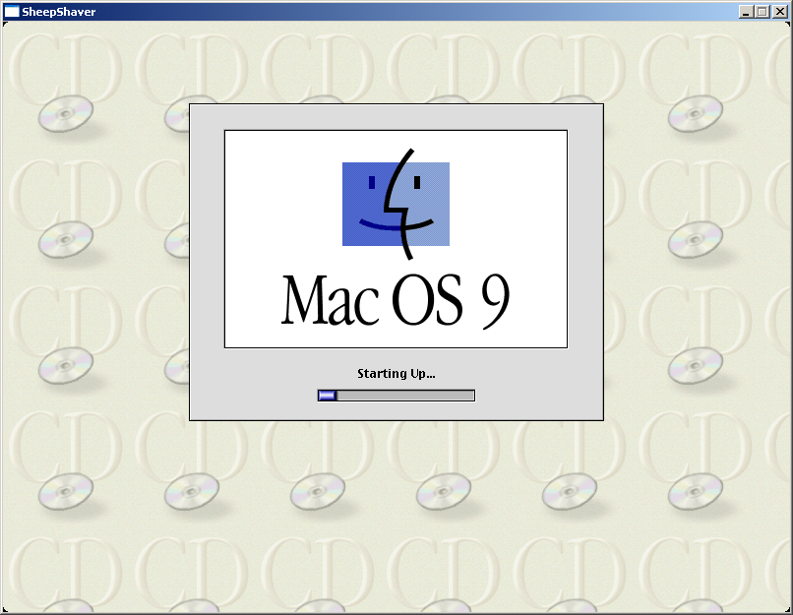

The “new hard drive” (hard file in SheepShaverGUI.exe) is “blank from the factory” and now needs to be formatted with a filesystem that Mac OS 9 can read.
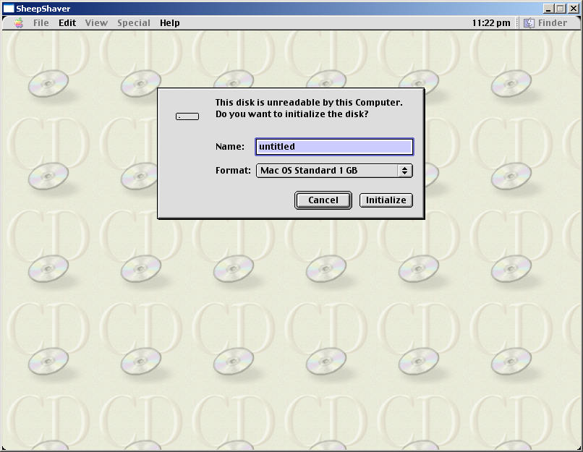

- I gave the name of my hard drive “MacOS9 HD”
- Important!! Select “Mac OS Extended xxMB” (where xx is the size you chose during creation of the hard drive file.
Mac OS Standard ⬄ HFS (Hierarchical File System)
Mac OS Extended ⬄ HFS+ (Hierarchical File System Plus)
Here is why: http://support.apple.com/kb/ht1604

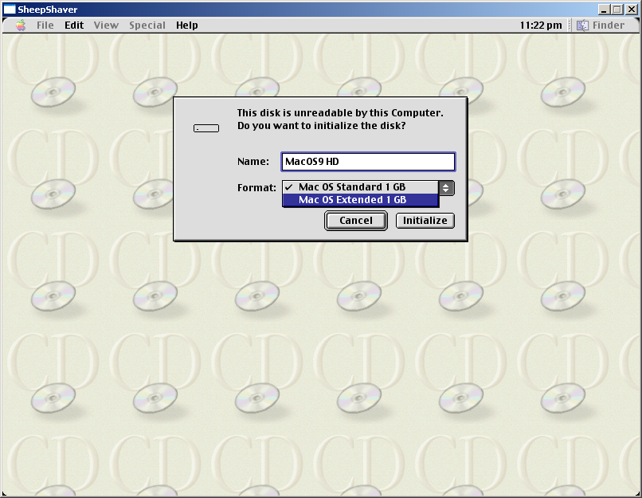

My result:

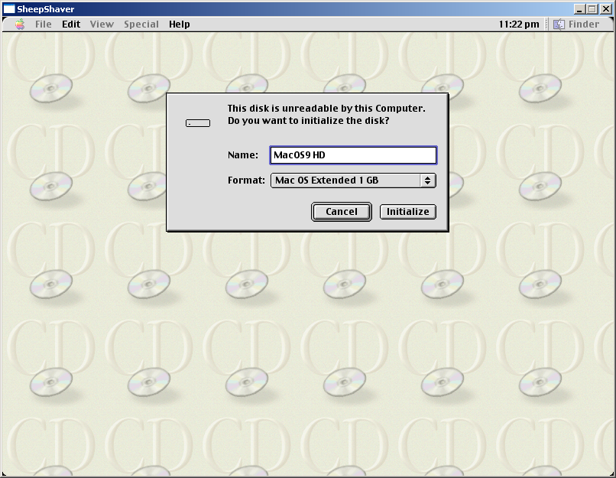

Click “Initialize” … the “hard drive” will be formatted with the HFS+ filesystem.

Warning before formatting

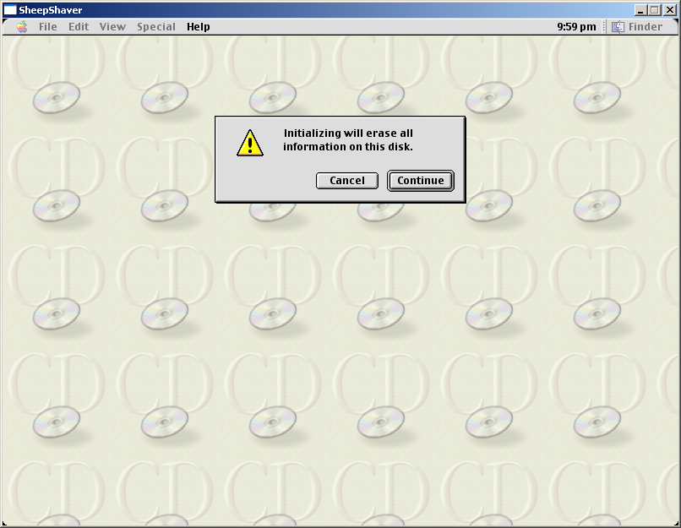
After the Mac OS 9 CD (or .iso) boots, you should see something similar to the picture below. FYI we are now booted off the CD-Rom

- The top-right icon is the Mac OS 9 CD; I am using a Mac OS 9.0.4 CD (.iso actually)
- The second icon “MacOS9 HD” is the 1024MB hard drive I created for my install
- The “My Computer” is the Windows PC. This is how you will access files on the Windows PC.

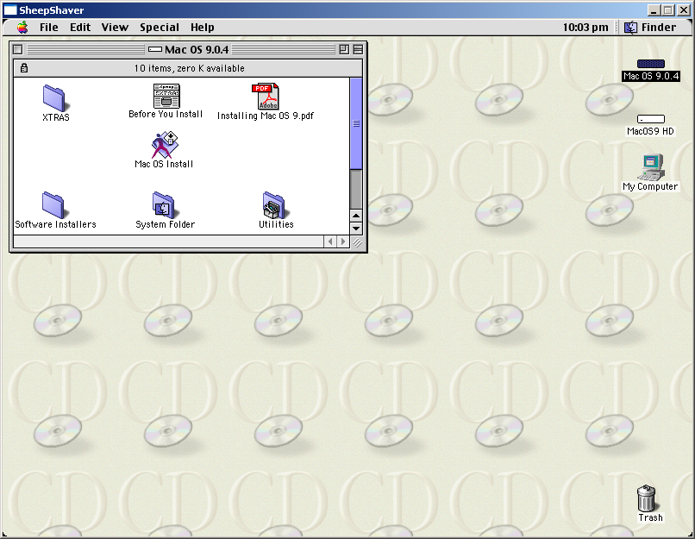
Go ahead and click on the “Mac OS Install”

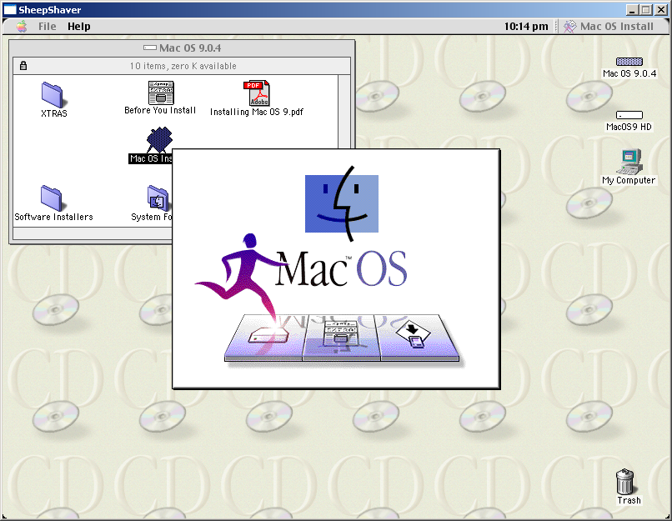
… and we are installing…
Select Country (if applicable, depends on your Mac OS 9 distro)
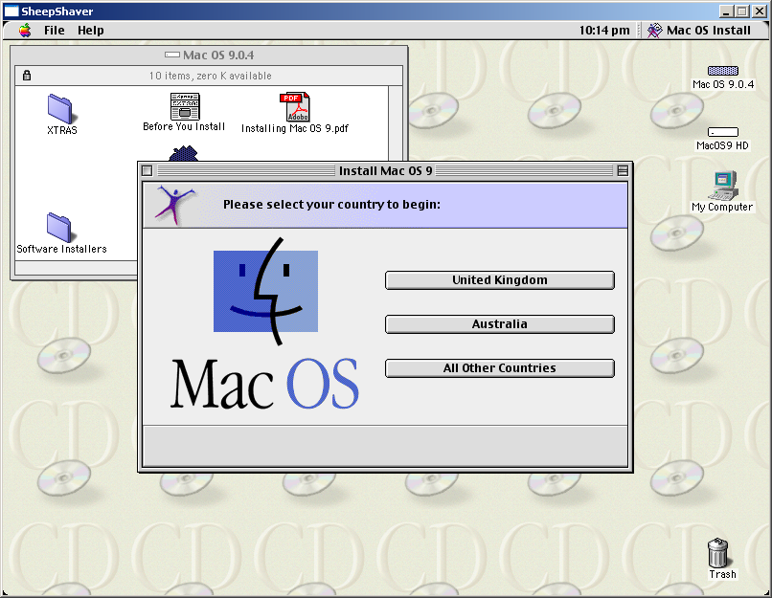

Click Continue

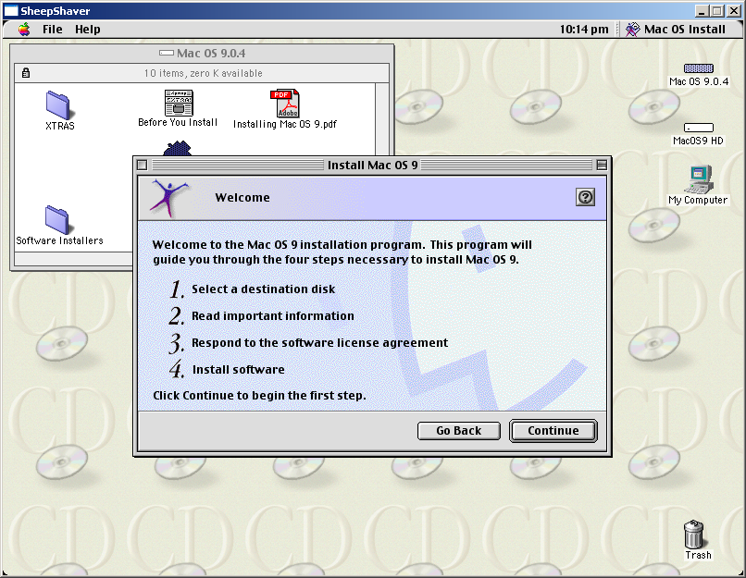

When you see this screen, click “Options”

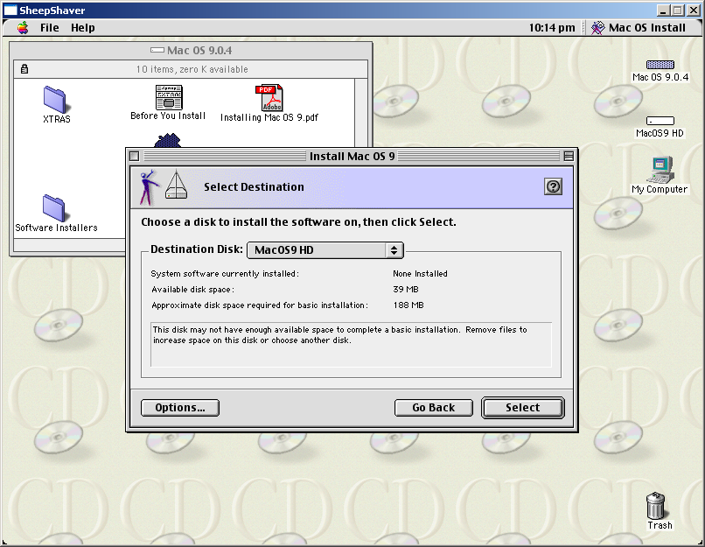

Select the checkbox “Perform a Clean Install” – note this is a clean install by default since the HD is blank, but if you re-install over top this HD file later on, you will want to select this option!

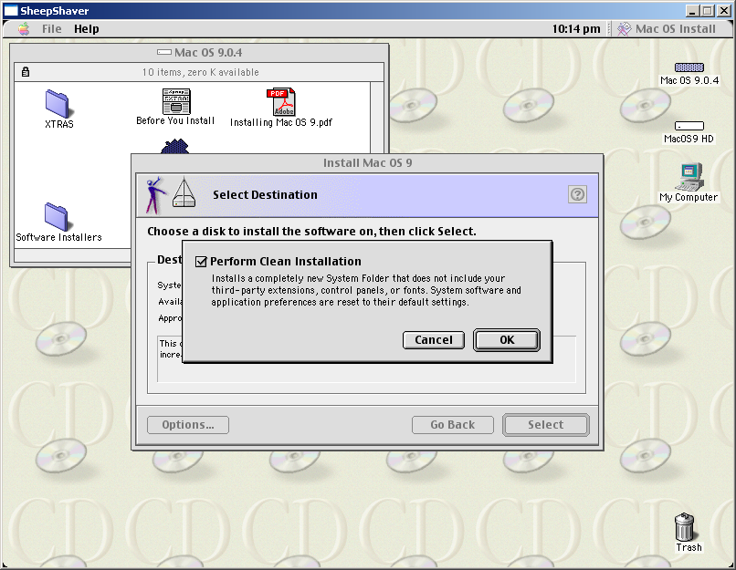

Click Continue

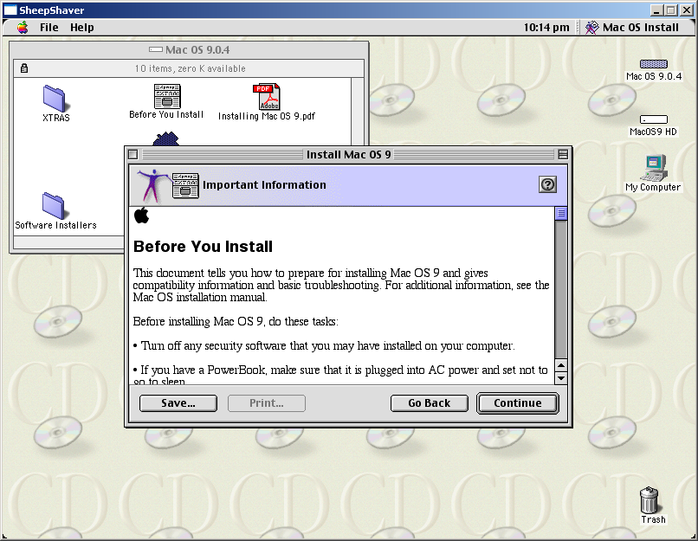

Continue
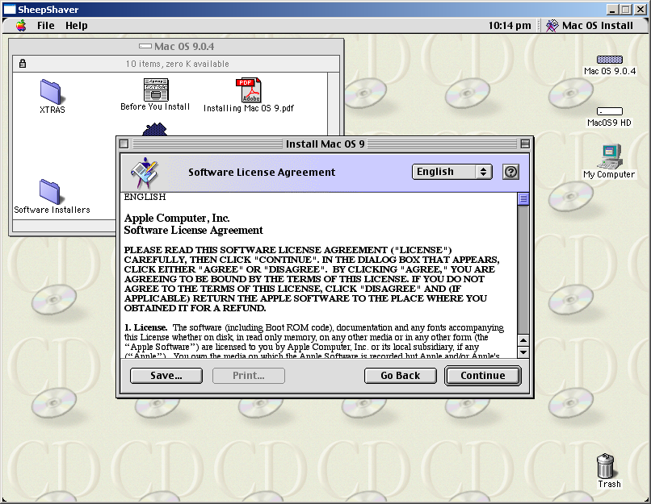

Agree
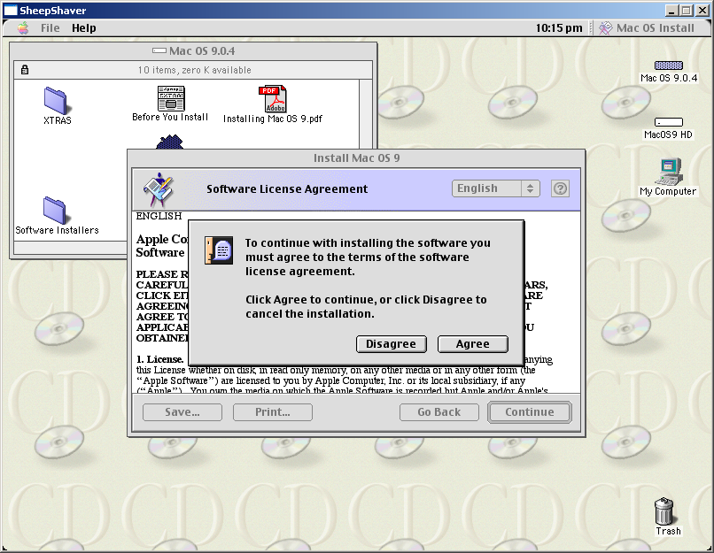

This is a completely optional step, you can just click “Start” here if you like. I chose the “Customize” option to remove some un-needed components:
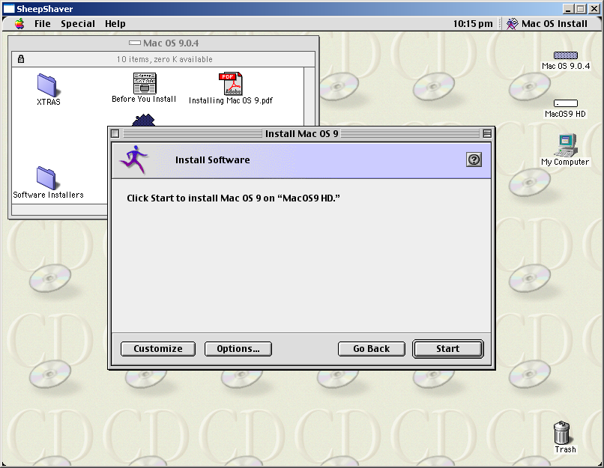

I removed the “Apple Remote Access” and the “Personal Web Sharing” components. I am sure there are more that can be removed, just haven’t experimented enough with it, and probably won’t make a difference anyway.

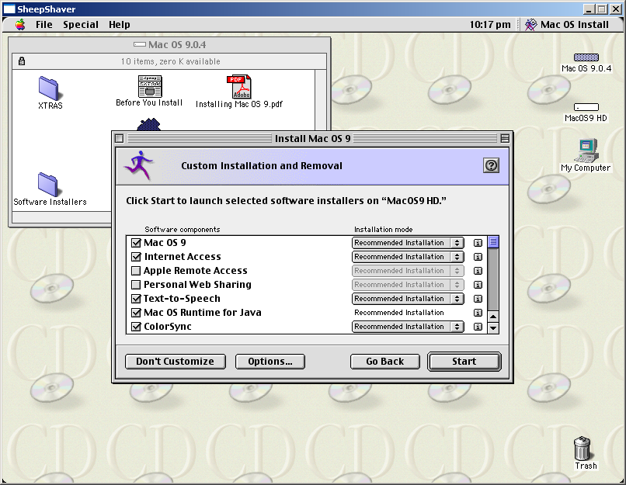

These should be checked by default, but click “Options” to verify. The Hard Disk Drivers are important.

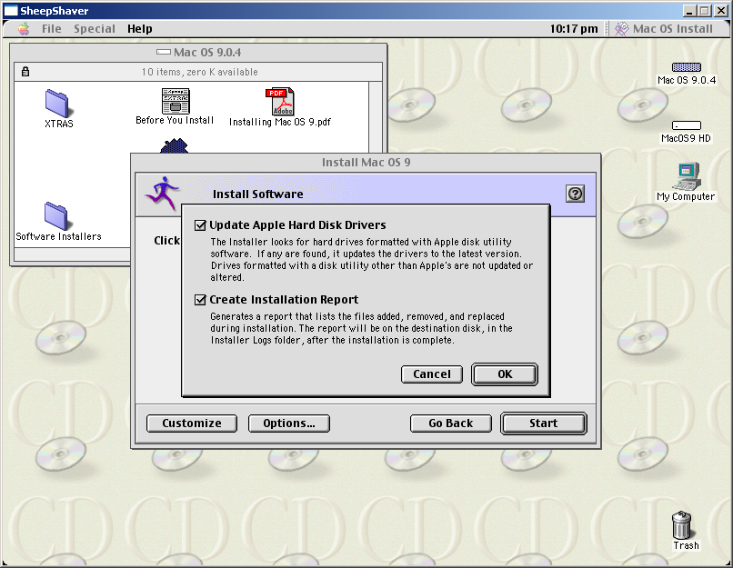

OS install begins…
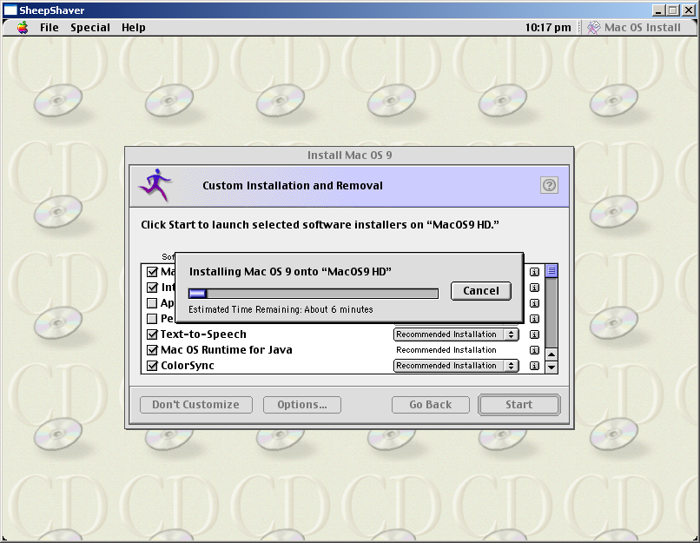

this can take a little while depending on the size of the HD you chose to format

// --- Need more screenshots for steps! -- //

Use Stuffit expander to expand JacqCAD inside the emulated environment!

Here is the briefest of reasons: Mac OS 9 uses a file fork (has the data) and a resource fork (has metadata). Mac OS 9 (and previous versions of Mac OS) does not use file extensions (like .doc or .pdf) like Windows, and this construct was used to open a file without a filename extension (like .doc or .pdf). In effect, there were no file extensions and the files were opened with the correct application. When native Mac OS 9 files are copied to a Windows directory, the resource information is stripped away.

We generally get around this problem by using DropStuff (Stuffit Standard), DropZip, or other zipping/encoding utilities to compress the files. See the helpful links for pages with more detailed information if you are really interested. Mac OS X does NOT have this problem and deals with this resource fork information as extended attributes just fine.

Note: “flat” files, such as .zip, .sit, .jpg, .tiff and etc. don’t have the problem. It only applies to Mac OS 9 executables and other types of files like this. The files saved by JacqCAD will be “flat” like these.

FYI the ROM from the iMac update 1.1 is about 2MB and I gave it the name MAC_OS_ROM_iMac (no Windows file extension) and put it in my ‘C:\Sheepshaver’ directory.

Helpful hints:
-- SheepShaver supports Copy-Paste of text between MacOS and the host OS

-- Optional (but nice to hear): In the MAC OS 9 Environment
Apple Menu → Control Panels → Appearance – sound tab – chose platinum sounds

Other Thoughts:
It has been many years, but I was trying to remember some of my favorite Mac OS 9 tweaks that could be used in this environment. Using the extensions manager comes to mind to disable un-needed extensions to give the OS more memory and CPU cycles, but this may be just picky given the physical underlying RAM and CPU.

Helpful links:
Running Classic Software on an Intel Mac (great reference, but some link s outdated)

The SheepShaver Chronicles, Part 1 (older reference, but still good info)

Mac OS 9:
Apple’s OS9 site
OS9forever.com

TomeViewer:
http://apple.wikia.com/wiki/TomeViewer

How to use TomeViewer
http://home.arcor.de/grouchosbox/tomeviewer.html

Mac OS 9 resource forks:
http://kb.iu.edu/data/aarp.html (best general explanation)
http://www.macwindows.com/tutfiles.html (good detailed explanation)
http://en.wikipedia.org/wiki/Resource_fork
http://en.wikipedia.org/wiki/Fork_%28filesystem%29
http://support.grouplogic.com/?p=1496

Thanks:
- Garth Fletcher - creator of JacqCAD.

- Gwenole Beauchesne - creator of SheepShaver. Without this, JacqCAD would be limited to old PPC based Macs.

- Cat_7 and Ronald P Regensburg for Emaculaion guides and contributions to the SheepShver community.

- Emaculation for hosting all the information I needed!

- GTK+ library publishers.

- Apple Inc.® - Mac OS 9 was one of the best operating systems of its day! Also for making the ROM files available as downloadable updates (to hardware) At the Apple WWDC in 2002, Steve jobs staged a mock funeral for OS 9

